**Practical No. 3**

**Constructors and method overloading**

**Program 3(a):**

Design a class complex for adding the two complex numbers and also show the use of constructor.

**Coding:**

#include<iostream.h>

#include<conio.h>

class complex

{

int x,y;

public:

complex()

{}

complex(int a,int b)

{

x=a;

y=b;

}

friend complex add(complex c1,complex c2);

void display()

{

if(y<0)

cout<<x<<y<<"i";

else

cout<<x<<"+i"<<y;

}

};

complex add(complex c1,complex c2)

{

complex c;

c.x=c1.x+c2.x;

c.y=c1.y+c2.y;

return c;

}

void main()

{

clrscr();

int x,y;

cout<<"Enter the real and imaginary part of the complex number:";

cin>>x>>y;

complex c1(x,y);

cout<<"Enter the real and imaginary part of a complex number:";

cin>>x>>y;

complex c2(x,y);

complex c3;

c3=add(c1,c2);

c3.display();

getch();

}

**Output:**

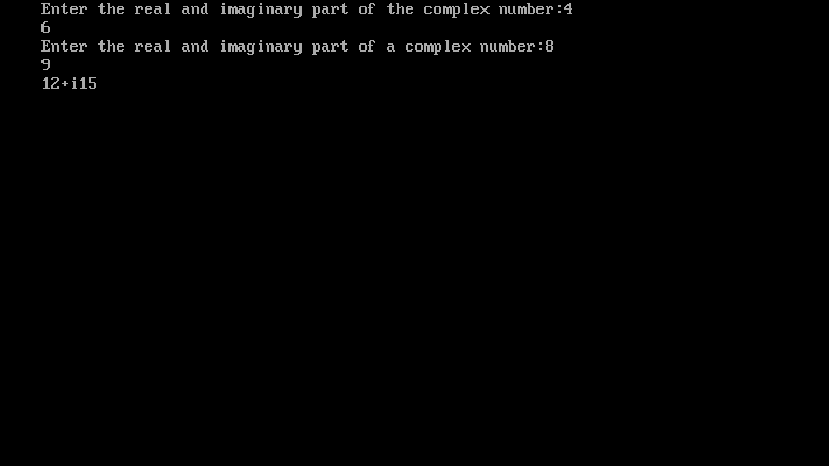

**Program 3(b):**

Design a class geometry containing the methods area() and volume() and also overloaded the area() function.

**Example:**

Write a program to calculate the area of triangle, recatangle and circle using function overloading. The program should be menu-driven. It should also calculate the volume for the spere in case if circle is user’s choice.

**Coding:**

#include<iostream.h>

#include<conio.h>

#include<math.h>

float volume(float r)

{

return(4*3.14/3*r*r*r);

}

float area(float r)

{

return(3.14*r*r);

}

float area(float l,float b)

{

return(l*b);

}

float area(float a,float b,float c)

{

float s,ar;

s=(a+b+c)/2;

ar=s*(s-a)*(s-b)*(s-c);

ar=pow(ar,0.5);

return ar;

}

void main()

{

clrscr();

int choice;

float x,y,z,a;

cout<<"1.Area of circle\n2.Area of rectangle\n3.Area of triangle\nEnter your choice:";

cin>>choice;

switch(choice)

{

case 1:cout<<"Enter the radius of the circle:";

cin>>x;

a=area(x);

cout<<"The area of circle="<<a<<endl;

a=volume(x);

cout<<"The volume of sphere="<<a<<endl;

break;

case 2:cout<<"Enter the length and breadth of the rectangle:"<<endl;

cin>>x>>y;

a=area(x,y);

cout<<"The area of rectangle="<<a<<endl;

break;

case 3:cout<<"Enter the length of three sides of the triangle:"<<endl;

cin>>x>>y>>z;

a=area(x,y,z);

cout<<"The area of triabgle="<<a<<endl;

break;

default:cout<<"Invalid Choice"<<endl;

}

getch();

}

**Output:**

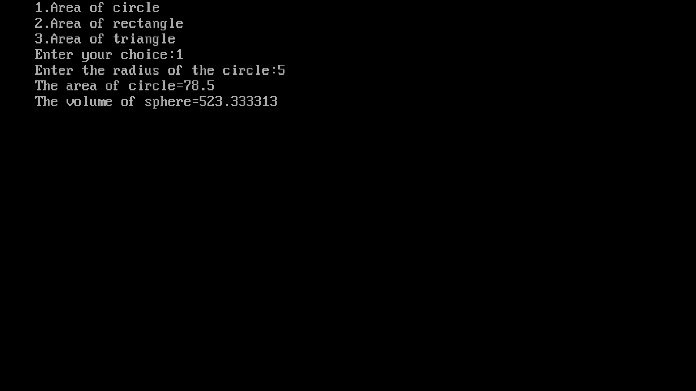

**Program 3(c):**

Design a class StaticDemo to show the implementation of static variable and static function.

**Coding:**

#include<iostream.h>

#include<conio.h>

class count

{

private:

static

int counter;

public:

count()

{

counter++;

}

static int display()

{

return counter;

}

};

int count::counter=0;

void main()

{

clrscr();

count c1;

cout<<"Number of objects:"<<c1.display()<<endl;

count c2;

count c3;

cout<<"Number of objects:"<<c1.display()<<endl;

getch();

}

**Output:**

